Gerhard von Bressensdorf
President

EFA – Hofbrunnstraße 13 – D-81479 München

Munich, 29/07/2026

Dear colleagues,

The project MERIT (Minimum European Requirements for Driving Instructor Training) has started. The enclosed questionnaire will help to provide a solid overview of the situation across Europe in the field of driving instructors. I would kindly ask you to fill in this questionnaire as precisely as possible, so that there is a solid basis on which to work in the rest of the project.

Please don’t hesitate to ask if you have trouble replying properly to a question. We need an up-to-date and reliable survey of the situation of driving instructors’ training in the EU and its neighbouring countries. Thank you very much for your effort.

This subject will be discussed at our forthcoming meeting in Greece. You will also be able to meet the members of MERIT’s scientific committee at our meeting later this year in the Netherlands.

Thank you again for your help. Please return the questionnaire by April 23.

The language of the questionnaire corresponds to the preferences indicated in our last meeting in Prague.

Kind regards

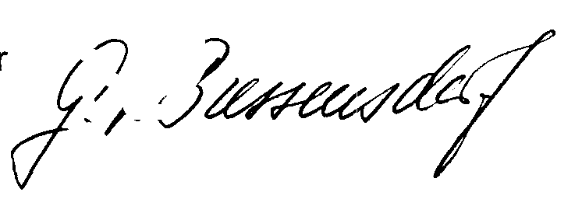
Gerhard von Bressensdorf
President

